Assignment 1: Maximizing Your LA Grade

1. design my own application:

Student A takes Data Structure this semester. The course has 10 for class participation,20 for programming assignment, and 15 for online quizzes, 55 for exams. But he only wants to spend 15 hours per week in DS.

If he spends 1hr/week reading the slides for lecture,he can get 2 for assignments,4 for online quizzes,2 for exams,1 for class participation

If he spends 1hr/week programming, he will get 5 for assignments,13 for online quizzes,8 for exams,6 for class participation

If he spends 1hr/week watching videos for DS, he will get 0 for assignments,0 for online quizzes,6 for exams,1 for class participation

If he spends 1hr/week discussing homework or contents for DS with friends, he will get 2 for assignments,0 for online quizzes,1 for exams,0 for class participation

Now he wants to know how many hours he should work on different kinds of efforts on ds can he maximize his grade

maxG(x,y) = 9x + 33y + 7z + 3w

subject to

x + y + z + w <= 15

2x +5y +2w <=20

4x + 13y <=15

2x + 8y + 6z + w <=55

x + 6y + z <=10

x,y,z,w >=0

there are c(5,4) = 5 cases, for each case

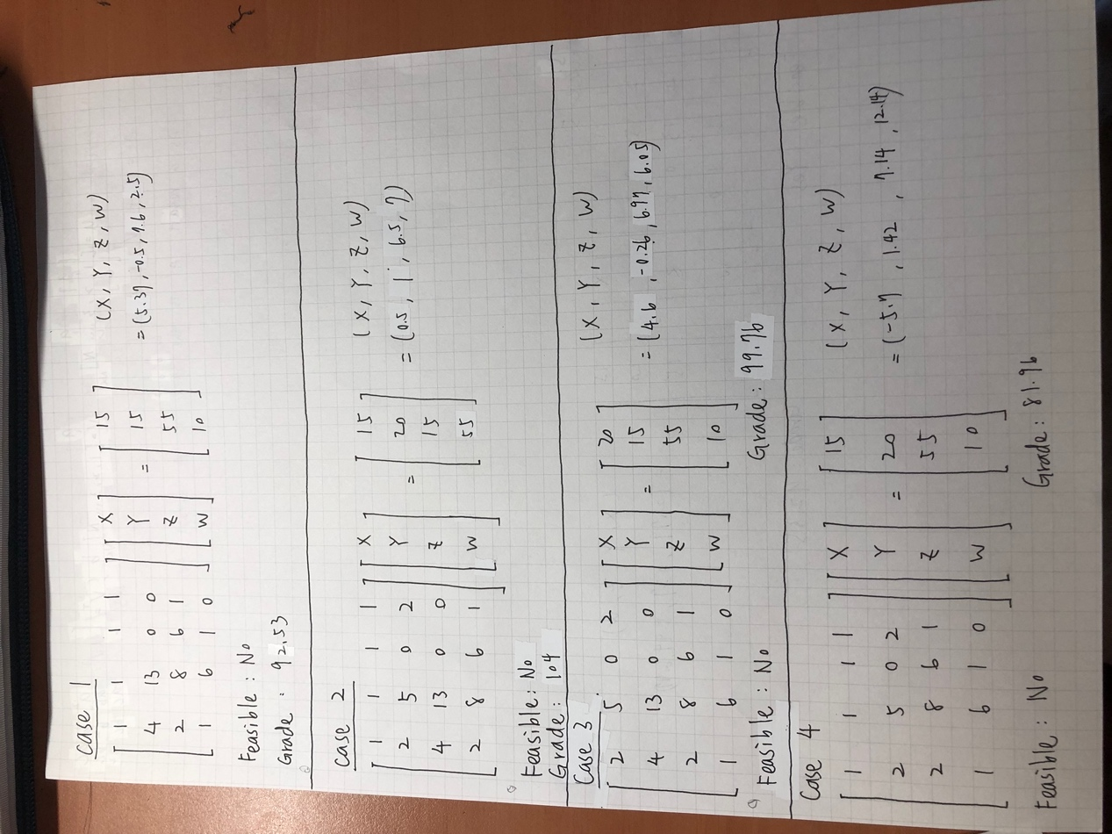

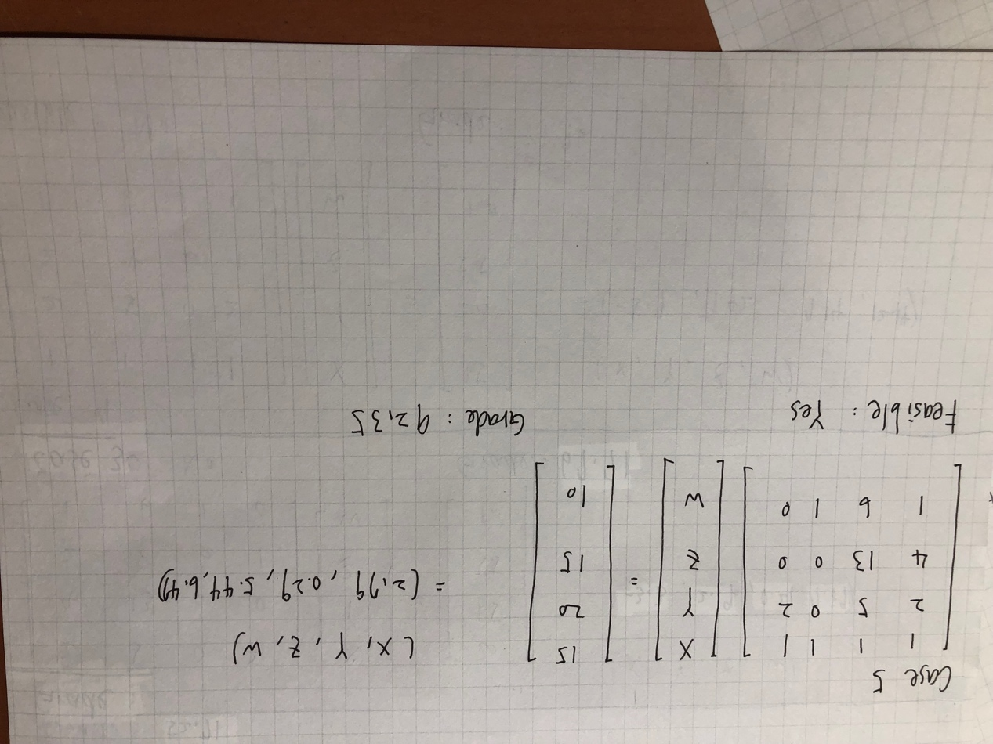

4.

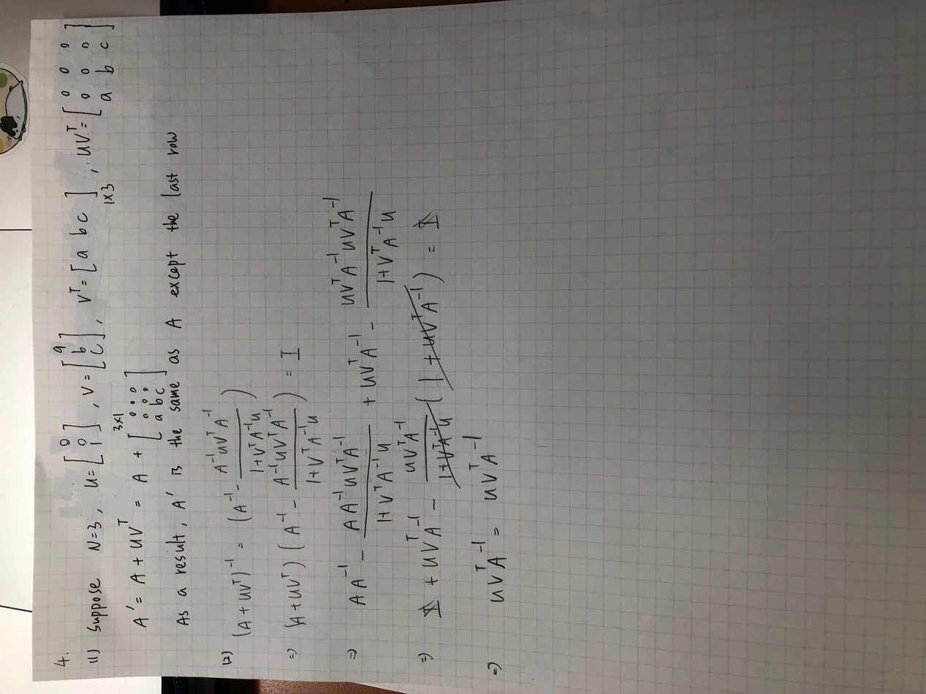

5.

We can shift the objective function and compare the intercept’s value to find the optimal https://www3.nd.edu/~apilking/Math10120/Lectures/Solutions/Solutions%20To%20Lectures%20copy/Topic23N1.pdf

Just the same as the method mentioned in the page 3 of the above address